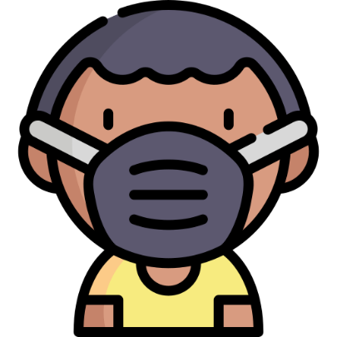

|  |
| --- |
| **Protection Webinar**  Hi Jeffy,  You are invited to join the Protection webinar on Tuesday at 12/30/1899 09:00:00.  See you soon! |